

AMERICAN INTERNATIONAL UNIVERSITY–BANGLADESH (AIUB)
Dept. of Computer Science
Faculty of Science and Technology

CSC 01409: PROGRAMMING IN PYTHON
Spring: 2025-20256
Section: [B]
Group No: 1512

Project Report On
Project Name [Password Vault]

Supervised By
Name | ID
1. MOHSIN IBNA HOSSAIN | 23-50194-1
MD. Tanzeem Rahat
Submitted By:

1. Introduction
Secure Password Vault CLI is a professional-grade terminal application built to provide users with a secure, offline environment for managing their digital credentials. In an era of increasing cyber threats, local-first security solutions ensure that sensitive data remains under the user's direct control, away from cloud-based vulnerabilities.

2. Key Features
- AES-128 Encryption: Uses the Fernet symmetric encryption standard to ensure all passwords are encrypted before storage.
- Password Generation: Integrated tool to generate cryptographically strong random passwords.
- Search & Management: Efficiently find, update, or delete credentials using multiple search parameters like Website or ID.
- Stealth Input: Implements hidden terminal input to prevent 'shoulder surfing' during password entry.
- Strength Validation: Real-time auditing of password strength based on length and character diversity.
- Summary Statistics: Provides a high-level overview of the vault status including total entries and unique domains.

3. System Architecture
The application follows a modular architecture, separating concerns across multiple components to ensure maintainability and scalability.
Module | Responsibility
main.py | The application entry point and main execution loop.
ui.py / menu.py | Handles user interaction and terminal formatting.
service.py | Contains core business logic and operation orchestration.
crypto_manager.py | Manages key generation and AES encryption/decryption.
storage.py | Handles JSON persistence and file I/O operations.
models.py | Defines the data structures for credentials.
utils.py | Helper functions for validation and strength checks.

4. Technologies Used
- Python 3.10+: Core programming language chosen for its robust standard libraries and ease of development.
- Cryptography (Fernet): Used for implementing a standard symmetric encryption scheme (AES in CBC mode with HMAC).
- Colorama: Provides cross-platform support for colorful terminal output, improving user experience.
- Tabulate: Used for generating clean, visually appealing tables for data display.

5. How to Run the Project
To get the project running on a local machine, follow these steps in a terminal or command prompt:
- Clone the repository to your local directory.
- git clone https://github.com/MIHMahmudEli/PasswordVault.git
- cd PasswordVault
- Set up a virtual environment (Optional but Recommended):
- Windows:
- python -m venv .venv
- .venv\Scripts\activate
- macOS/Linux::
- python3 -m venv .venv
- source .venv/bin/activate
- Install dependencies:
- pip install -r requirements.txt
- Run the application:
- python main.py

Note: Upon the first execution, a 'secret.key' file will be generated in your project directory. This key is essential for accessing your encrypted data. Please keep it safe and avoid sharing it.

6. Security Considerations
Security is handled through a combination of industry-standard encryption and secure coding practices:
- - Local Storage: Data is stored in 'passwords.json' which is only accessible on the local machine.
- Secret Key: A unique 'secret.key' is used for each installation. This key is never stored in the data file.
- No Plaintext: Passwords are NEVER stored in plaintext. They are encrypted at the service layer before reaching storage.

7. Conclusion
The Secure Password Vault CLI successfully demonstrates a practical application of security principles in a user-friendly tool. By leveraging modern libraries and a modular design, it provides a stable and secure solution for password management.
8. Screenshots
8.1 Add a new password:
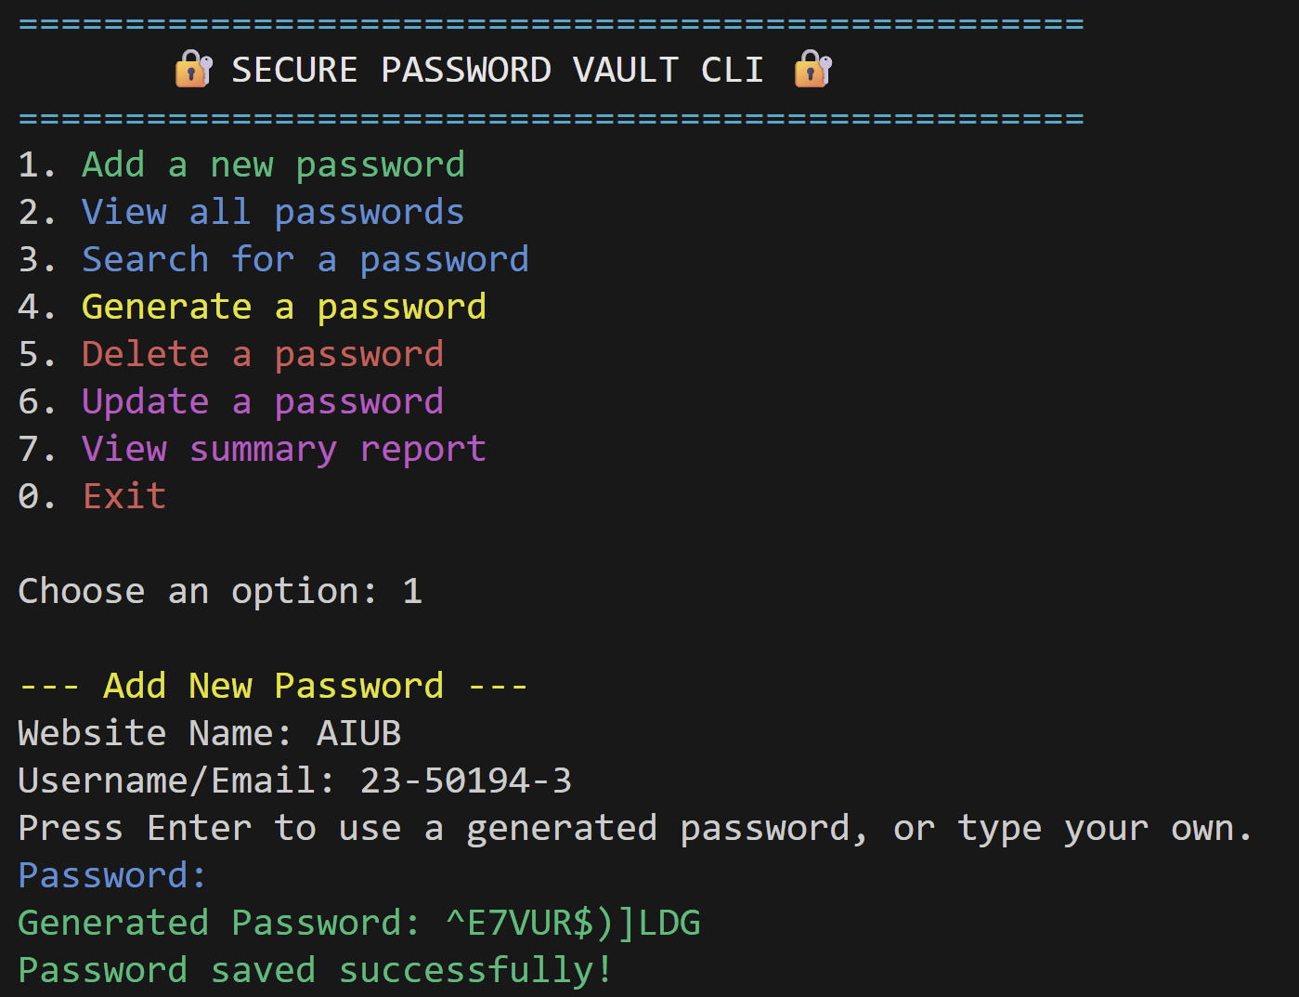

8.2 View all passwords
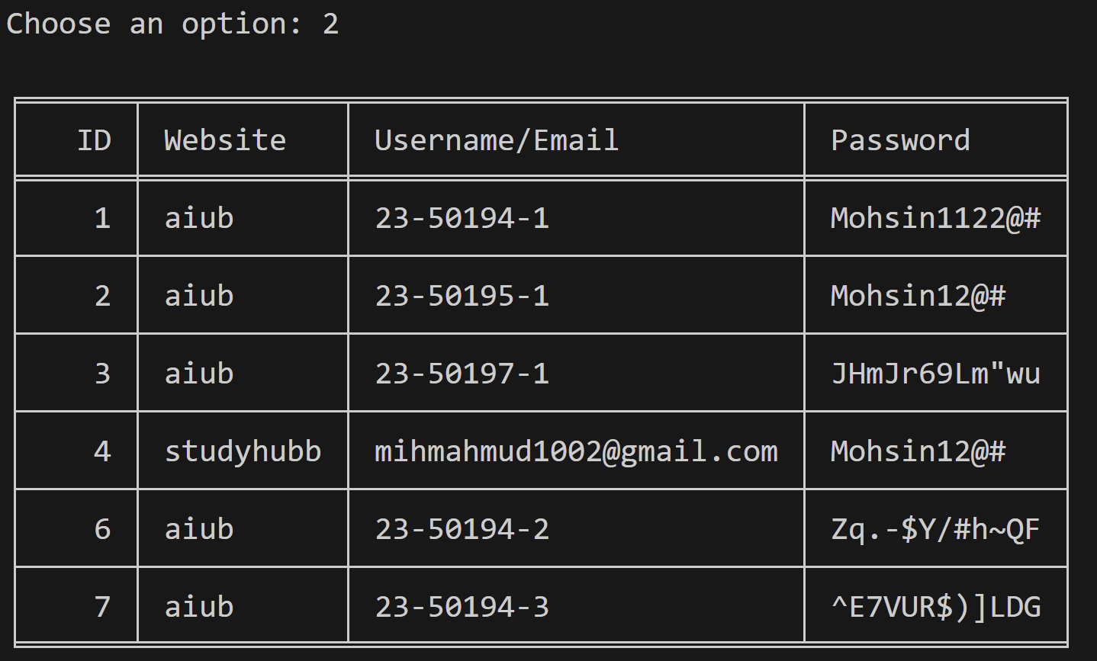

8.3 Search for a password
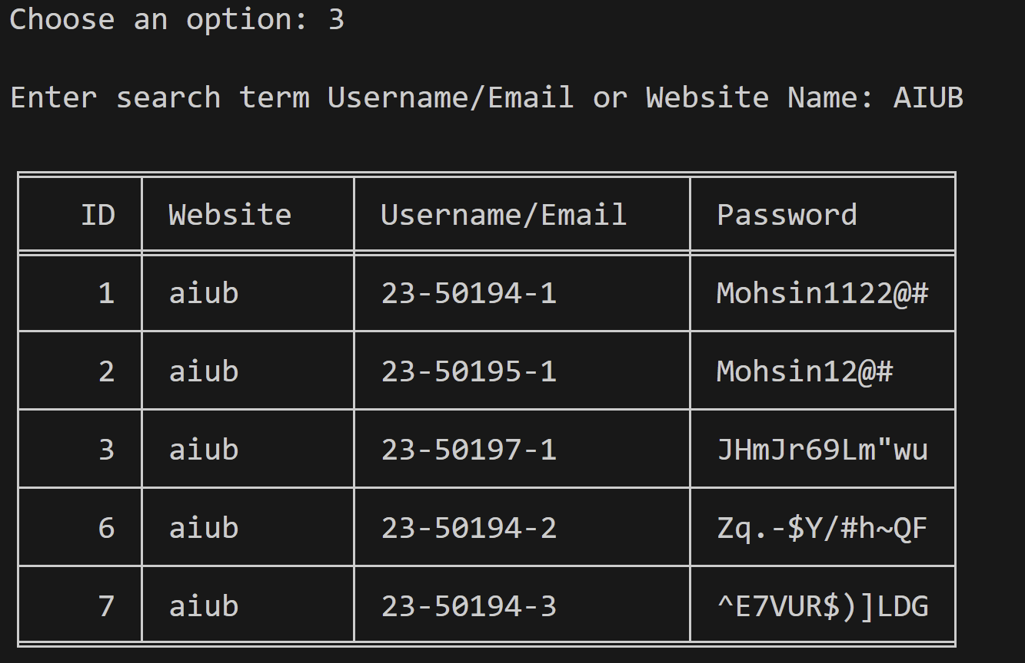

8. 4 Generate a password
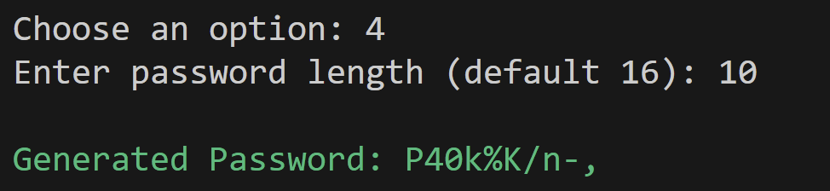

8.5 Delete a password
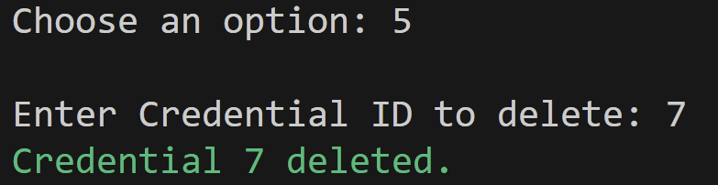

8.6 Update a password
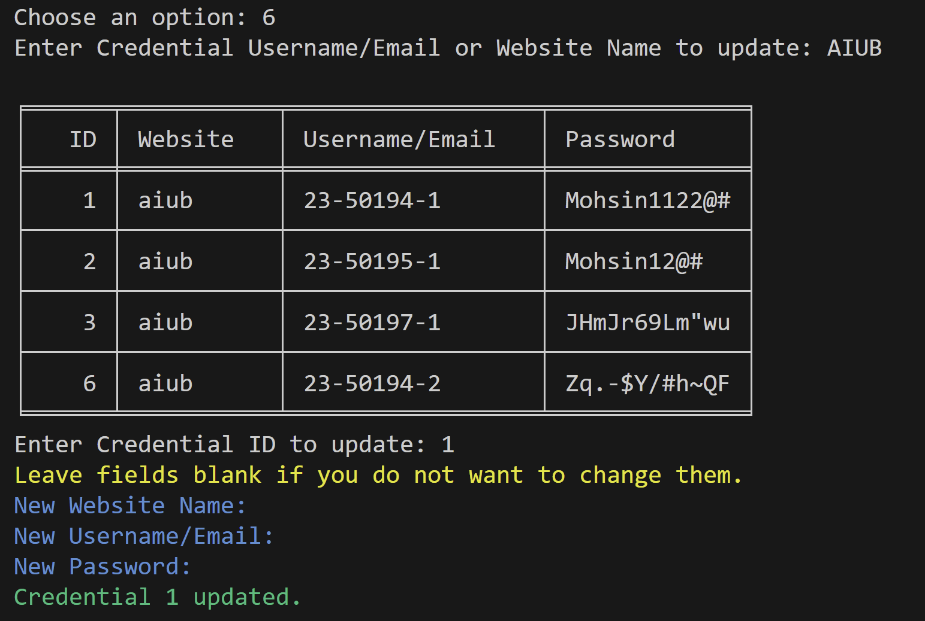

8. 7 View summary report
